**JAVA CLASS: ->**

**02-Oct-2023: -**

**(Writes once run anywhere #WORA) Dialogue**

**Java is a versatile high level platform independent programming language which support oops concept very strongly.**

**3 categories of programming language: -**

interpreted, compile, interpreted compile prog.Lang.

**Java is interpreted compile programming language.**

**Java applications :->**

* Console based application.
* Windows base application.
* Web base app.
* Enterprise base app.
* Distributed app.
* Mobile app.
* Embedded app.

**Features of Java:->**

1. Robust
2. Dynamic
3. Portable
4. Secure
5. Platform Independent(*important*)
6. Supports OOPS. (*important*)
7. Concurrency.
8. Distributed.
9. Flexibility.
10. Open Source.

JDK vs JRE vs JVM :->

JDK: - Java Development Kit.

JRE: - Java Runtime Environment.

JVM: - Java Virtual Machine.

JVM is platform dependent.

**Java Strength:->**

Platform Independency.

Platform => Operating System + Hardware Configuration.

Question: How it is platform independent?

Ans: -

because of byte coded class file and JVM JAVA is platform independent.

Compilation of java is byte coded then source code in class such as A. class.

Class file is Byte coded machine language, and converts into binary code by using JVM and then its compiled.

JVM is Interpreter of Java,

hence it is platform independent.

For every Operating system JVM is different.

**2. OOPS:->**

**(Object Oriented Programming Structure)**

four pillars of OOPS

Abstraction, Inheritance, polymorphism, Encapsulation.

**ABSTRACTION :->**

It is responsible to hide internal complexity and represent it in simplified manner.

E.g.: Container having book, pencil, pen, etc which are totally independent.

**POLYMORPHISM :->**

When we use one thing in different manner according to our requirement is called polymorphism.

**ENCAPSULATION :->**

It is responsible to hide internal complexity and binds them together for accomplishing some fruitful work.

E.g.: Car, in which without any single part car will not work.

**INHERITANCE :->**

If we establish parent child relationship between two or more than two entities, you authorize child entity to access any property of parent entity except private property.

It enhances the concept of Reusability of code.

**DATA TYPES: -**

It is the reserve keywords and identifiers which is responsible to define nature of data which it holds.

**It is of two types: -**

* 1. Primitive

1. byte (1 bit), short (2 bit), int (4bit), long (8 bit) (default value = 0)
2. float (4 bit), double (8bit) (default value = 0.0)
3. char (2 bit) (default value = null)
4. boolean (1 bit) (t/f) (default value = true)
   1. Non primitive
5. Predefine

All class, interface, arrays, enumeration and object which is already present in system.

e.g., string

1. User defines

which is define by user.

Java has total 49 working keywords and always written in small letters

**CLASS: -**

It is collection of variables, methods and object.

It is collection of similar types of objects.

It defines object conceptually.

It is the blueprint of object. (Most important)

**Syntax of class: -**

class is keyword and always written with small alphabet

**[**Access specifiers**] [**Modifier**]** class ClassName {

} // [] are optional

***Access specifiers: -***

It is the keyword which is responsible to define the scope of accessibility of any class, variable or method.

1. public
2. protected
3. default
4. private

***Modifier: -***

It is the reserved keyword which is responsible to modify the normal behaviour of any class, method or variable and assign certain restriction over that.

1. final
2. abstract
3. static

***ClassName: -***

1. ClassName can be any name upto 120 characters.
2. ClassName should not starts start with numeric value.
3. Only two symbols can be used $ and _.
4. ClassName should be start with capital letter.

Along with outer class we can use only use public and default access specifiers but along with inner class we can use all 4-access specifier.

***Variables: -***

1. **Instance (Object) Variable: -** Any non-static variable which is define or declare inside the class but outside of any method becomes instance variable.

It has two properties: -

1. It can be accessible anywhere and at any time inside the class.
2. All the objects of the class have their own copy of instance variable any change made by any object doesn’t affect any object.
3. **Static (class) Variable: -** If we use static modifier along with any instance variable then that variable becomes static.

Properties: -

1. It is same as instance variable
2. All the objects of class share same static variable now any change made by any object affects the other object also
3. **Local Variable: -** Any variable define inside the particular method becomes local variable of that method.

It cannot be declared it is defined.

E.g., int a; declaration

a = 10; initialization

int a = 10; define / implementation

Properties: -

1. Local variable cannot accessible outside the method.

***Method: -***

**[**Access specifiers**] [**Modifier**]** returnType methodName ([parameter]) {

} // [] are optional

methodName should be start with small letter.

***returnType*: -** it may be any data type whether it is primitive or non-primitive.

**LOOPS: -**

Use to access statement repeatedly.

Types of the loops: -

* 1. Do while: -

It accesses at least one time. When you want to handle cyclic iteration.

* 1. While: -

It is used to handle infinite iteration or we don’t know how many iterations are there.

* 1. For: -

When no of iteration is finite i.e., know upper and lower value.

* 1. For each: -

It is use to access existing collection.

E.g., int arr [] = {1, 2, 3, 4, 5}

for (int x: arr) {

sop(x);

}

**ARRAY: -**

Java. Utility package has all function regarding array.

Array is the collection of similar data having same data type.

***Syntax: -***

int arr []; 🡪 declaration.

arr = new int [5]; 🡪 initialization

int b [] = {1, 2, 3, 4, 5}; 🡪 implementation

Types of arrays: -

* + 1. One dimensional.
    2. Multi-dimensional.
    3. Jagged Array: -

It is also type of 2d array. Elements in row are not same.

E.g., 1 2 3 4 5

1 2 3



4 5 6 7

int ja [] [] = new int [3] [];

ja [0] = new int [5];

ja [1] = new int [3];

ja [2] = new int [4];

OR

{

{1, 2, 3, 4, 5},

{1, 2, 3},

{4, 5, 6, 7}

}

**By Default, java. lang is imported.**

**Mostly used package is java. util.**

**Object class is only package which is inherited.**

**METHOD OVERLODING: -**

It is also known as static polymorphism.

When we create more than one method having same name but differ in signature within same class is called method overloading.

**Why we use method overloading?**

**Ans.** Same functionality but different behaviour.

Signature = No of parameter + their data type.

E.g.,

void show () {…}

void show (int x) {…}

int show (double x) {…}

void show (int x, double y) {…}

**CONSTRUCTOR: -**

It looks like a method bit has certain differences over method: -

* + - 1. Its name must be same as class name.
      2. It has no return type not even void.

Similarities with method: -

* + - * 1. It can be parameterized like method that’s why it can be overloaded like method.

Class Cdac {

Cdac (int a) {}

Cdac () {}

}

Uses: -

It is useful to initialise the instance variable.

It is useful to allocate space in memory to all non-static properties of class.

It is useful to class other constructor of same class.

It is useful to call parent/base class constructor.

**INHERITANCE: -**

It is one of the properties of OOPS in which we establish parent child relationship between two or more than two classes and authorized child class (derived class) it accesses any property of parent class (base class) except private property by using **extends** **keyword**.

Types of inheritance: -

Single/Simple: -

[P]

[C]

E.g.,

package inheritance. single;

class Parent {

int a =10;

void show () {

Sop ("a = "+a);

}

}

class Child extends Parent {

int b = 20;

void display () {

Sop ("b = "+b);

}

}

public class SingleInheritance {

public static void main (String [] args) {

Child c = new Child ();

c.show ();

c.display ();

}

}

Multiple: -

[P1] [P2] [P3]

[C]

Multilevel: -

[GP]

[P]

[C]

Hybrid: -

[GP1] [GP2] [GP3]

[P]

[C]

Hierarchical: -

[P]

[C1] [C2] [C3]

**Java does not support Multiple inheritance due to which it also not supports Hybrid inheritance.**

**METHOD OVERRIDING: -**

When we create a method in derived class which is already available in its base class i.e., the method having **same name and same** **signature** is called method overriding.

**It is a type of run/dynamic polymorphism.**

Association

**Has – a RELATION: -**

Types of has – a relation: -

Aggregation

Composition

* Association
* Aggregation
* Composition

**Association: -**

If two different entity works together by using has -a relationship then it will follow the concept of association if both the entity can exist independently.

E.g., Person and address.

**Aggregation: -**

If group of one entity associate with other entity and if part of group survives independently then it is known as aggression relationship.

E.g., Library and book.

**Composition: -**

If both the entity which are involved in association cannot exist independently without each other then it would be the composition type relationship.

E.g., Car and engine.

**THIS AND SUPER: -**

**this: -**

It is a keyword which is responsible to refer class property it can be use to overcome variable hiding which is generated due to same local as well as instance variable.

Its second use is to call other constructor of same class. (It must be first line)

E.g.,

Class A {

int a = 10;

void show () {

int a = 100;

sop (a);

sop (this. a);

}

**super: -**

It is keyword which is responsible to overcome variable hiding which is generated due to same instance variable of derived class and base class also.

It is useful to call base class constructor.

It is also useful to call base class overridden method.

E.g.,

class P {

int a = 10;

}

class Q extents P {

int a = 100;

void show () {

sop(a);

sop (super. a);}  
}

**ABSTRACTION: -**

**Abstract Class: -**

When we use abstract modifier along with any class then that class becomes abstract.

Now we cannot create its object so for assessing its property it becomes mandatory to inherit such type of class by some non-abstract class.

It may or may not contain abstract method.

**Abstract Method: -**

When we use abstract modifier along with any method then that method becomes abstract.

Now we can not implement such type of method it should be declare only.

It must be in abstract class.

**E.g.,** abstract void show;

**Note: - It is compulsion for derived class of any abstract class to implement abstract method.**

**INTERFACE: -**

Since java does not support multiple inheritance in terms of class which was the violation of Oops concept so for overcoming from this violation interface is introduce and we can inherit multiple interfaces in class by using implements keyword.

**Properties of interface: -**

All variable inside the interface will be public, static and final by default.

It contains all abstract methods inside the interface will be public and abstract by default.

Interface may contain default and static method (jdk 1.8).

It may contain private as well as private static method.

We cannot create its object like abstract class.

It is compulsion for not abstract derived class of interface to implement all abstract method of all interfaces.

**Types of Interfaces: -**

**Normal Interface**

**Functional Interface: 🡺**

Only one abstract method.

**E.g.,** Runnable, cloneable, comparable etc.

**Marker Interface:** 🡺

No abstract method.

**E.g.,** Serializable

**TYPE CASTING: -**

Two types: -

* + 1. Implicit

**E.g.,** int x =10;

Double d = x;

1. Explicit

**E.g.,**

Double d = 10.23;

int x = (int) d;

* + 1. Upcasting

**E.g.,**

Parent p = new Child ();

* + 1. Down casting

**E.g.,**

Child c = (Child) new Parent ();

**INNER CLASS (Nested Class): -**

|  |  |
| --- | --- |
| **Outer class** | **Inner Class** |
| Only default and public are use | All four-access specifier can be use |
| Can be Final, abstract but not static | We can use static with inner class |

If we create any class inside any class is known as inner class or nested class.

We introduce this concept in java for strengthen the property of abstraction and encapsulation in java.

Properties: -

* Along with nested class we can use all types of access specifier.
* It can be static.

**TYPES: -**

* + - 1. Static inner class: -
      2. Non static inner class: -
      3. Anonymous inner class: - No class name. It can never be outer class.

**LAMBDA EXPRESSION: -** (Introduced in jdk 8)

Method without name.

It is an Anonymous function which is responsible to confine the code and it can be accessible by using functional interface.

**E.g.,**

|  |  |
| --- | --- |
| **Normal Method** | **Lambda Method** |
| public void show () {  Sop (“I’m normal method”);  } | ( ) -> {  Sop (“I’m now lambda”);  } |
|  |  |
| public int sum (int x, int y){  return (x+y);  } | (x, y) -> x+ y; |
| public int square (int no){  for (int i = 1; i < 10; i++) {  Sop (no * i);  }  return no;  } | (no) -> {for (int i = 1; i < 10; i++) {  Sop (no * i);  return no;  } |

**PACKAGE: -**

It is the collection of certain class and interfaces which is responsible to do some specific type of task collectively.

It looks like a folder but has certain differences

* In the case of package, we need to declare folder name as a package name inside the file.
* It must be the first line of your source code.
* Declaration: - package package_name;

**Uses: -**

* It is useful to arrange file systematically at project level.
* It is useful to avoid many conflicts.
* It is useful to provide abstraction.

Protected can be access by anyone in package but outside the package only accessible by child.

Static import is responsible to provide all static properties of any class for direct use.

(Without using classname we can use its properties).

**JVM ARCHITECTURE: -**

Stages of JVM after receiving class file

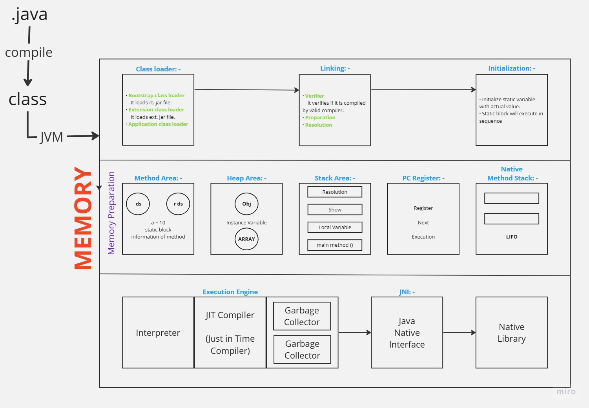

**Garbage collector: -**

It is the mechanism provided by JVM which is responsible to free space in memory which is created by reference variable and it invoke automatically by JVM at particular time intervals.

Can be call excessively using System. gc ();

**finalize (): -** (अंतिम इच्छा)

It is use to free foreign resources. It is callback method.

**E.g.,**

finalize () {

con. close ();

file. close ();

}

**STRING: -**

**C++ 🡺** It is an array of character.

**OOPS** 🡺 It is sequence of character.

**Java 🡺** It is a final class in java which define it as a sequence of character.

**Properties: -**

1. It is immutable by nature

Non-Changeable. It creates a memory scape which cannot be overwritten.

1. It is synchronized by nature.

**Two Ways for defining string: -**

* + - * 1. String Literal

String str = “Soft Polynomials”;

* + - * 1. By creating object using new keyword

String str = new String (“Soft Polynomials”);

**Note: -** If we create a object of string using **new** keyword first time then two object are created physically in memory one in normal **Heap memory** and second in **String pool**.

|  |  |  |  |
| --- | --- | --- | --- |
| **Heap Memory** | | **Stack** | |
| 2010  2020 | String Constant Pool  Cdac | s3  s2  s1  s | 1010  1010  2020  2010 |

String s = new String(“Cdac”);

String s1 = new String(“Cdac”);

String s2 = new String(“Cdac”);

String s2 = new String(“Cdac”);

String s3 = new String(“Cdac”);

s == s1 = false;

s == s2 = false;

s2 == s3 = True;

**String constant Pool: -**

It is the reserved memory are a of heap memory which is created by string literals. In this memory area duplicity of object is not allowed so that we can we use memory more efficiently.

|  |  |  |
| --- | --- | --- |
| String | String Buffer | String Builder |
| Differences: - | | |
| Immutable | Mutable | Mutable |
| Synchronized | Synchronized | Non-synchronized |
| Slow performance | Slow performance | Fast performance |
| Methods: - | | |
| String s1 = “Ramesh”;  String s2 = “Kapgate”;  s1 + s2;  String s3 = s1. concat(s2);  Sop(s1); //Ramesh  Sop(s2); //Kapgate  Sop(s3); //Ramesh Kapgate | s1. append(s2);  Sop (s1); // Ramesh Kapgate  s1. reverse ();  Sop(s1); //hsemaR | |

indexOf ()

Searching

lastIndexOf ()

indexOf () 🡪

String str = “My name is Khan. I’m not terrorist. I’m Sharukh Khan one of the Bollywood actors.”

🡨lastIndexOf ()

int x = str.indexOf (‘K’); //11

str.indexOf (‘K’,12); //25

str.indexOf (“Khan”); //11

str.charAt (11); //K

String s [] = str.split (“”); // to find number of words

char a [] = str.toCharArray (); // it will give character

s = “ ”;

str.isEmpty (); // false as it has blank

Gives boolean as answer

str.isBlank (); // true because there is nothing in it

s1 = “Anup”;

s2 = “anup”;

Sop (s1.compareTo (s2)); \\ -32 ASCII value 65 – 97 = -32

s1.compareToIgnoreCase (s2); \\ 0 as it ignore the case

**WRAPPER CLASSES: -**

|  |  |
| --- | --- |
| **Primitive** | **Wrapper Class** |
| int | Integer |
| byte | Byte |
| short | Short |
| long | Long |
| float | Float |
| double | Double |
| boolean | Boolean |
| char | Character |

In java all eight primitive data types have their corresponding build-in classes known as wrapper class.

It is useful to represent primitive data in object format.

To convert one data type to another we use parsing method.

**E.g.,**

Upto jdk 5;

int i = 10;

Integer x = new Integer(i); //Primitive 🡪 Reference = Boxing

int a = x.intValue(); //Reference 🡪 Primitive = Unboxing

After jdk 5

Integer x = i; // Auto Boxing

int a =x; // Auto Unboxing

**Boxing: -**

Conversion of primitive data to its corresponding to reference type is known as boxing.

**Unboxing: -**

Conversion of reference type data to its corresponding to primitive is known as boxing.

**Constant Pool: -**

valueOf () method is use.

|  |  |  |
| --- | --- | --- |
| **Family** |  | **Range** |
| byte, short, int, long | 🡪 | -128 to 127 |
| float, double | 🡪 | Constant pool is not available |
| boolean | 🡪 | true/false |
| char | 🡪 | ‘\u0000’ to ‘\u007f’ |

**EXCEPTION: -**

Difference between error and exception: -

|  |  |
| --- | --- |
| **Exception** | **Error** |
| * It is the problem which is generated due to faulty logical code. | * It is system generated problem. |
| * It can be handled by the programmer. | * It cannot be handled by the programmer. It should be corrected. |
| E.g., Arithmetic exception | E.g., Syntax error |

Hierarchy of Exception: -

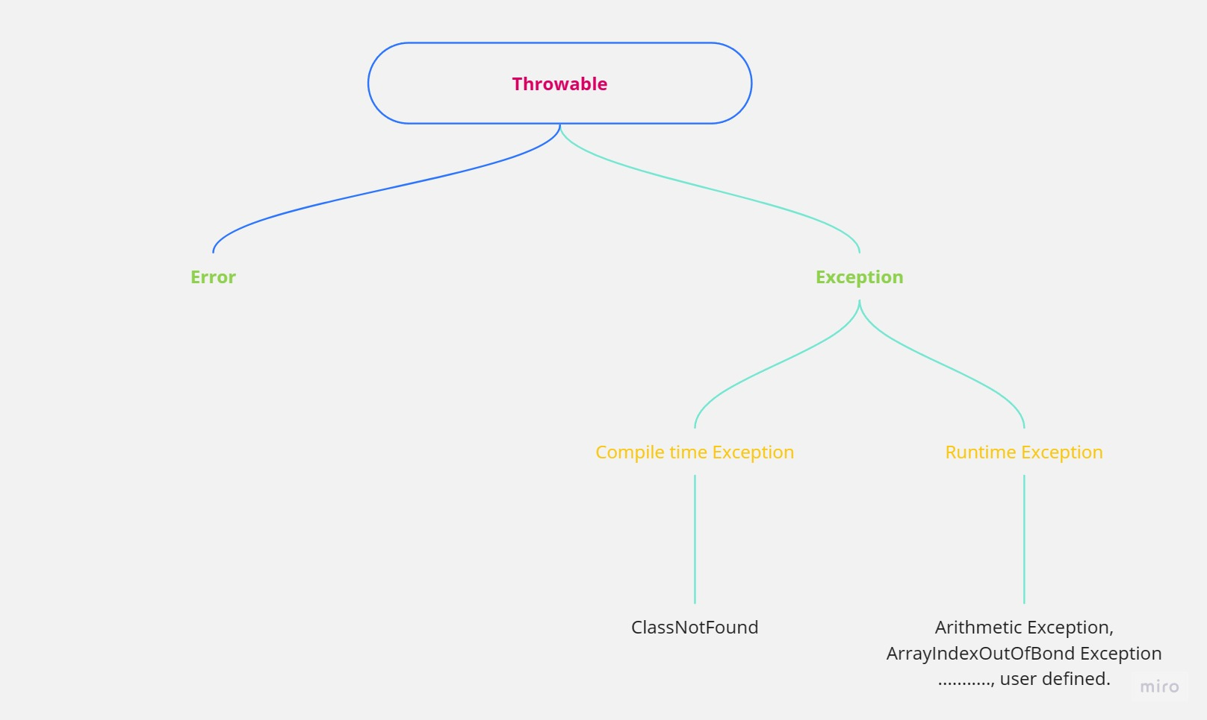

***NOTE: - We can create our own exception by inheriting either throwable class or exception or runtime exception class***

Type of Exception: -

Checked (Compile time) Exception: -

It is the exception which is recognized by our compiler and does not allow to compile the code is called compile/checked exception.

**E.g.,** ClassNotFound Exception, SQL Exception

Unchecked (Runtime) Exception: -

It is the exception which is recognized by our compiler and allow to compile the code but it generates problem at runtime is called Runtime/Unchecked exception.

**E.g.,** Arithmetic Exception, ArrayIndexOutOfBond Exception

**EXCEPTION HANDELING: -**

In java we have 5 keywords to handle exception: -

Note: - It will be a part of method

try block: -

Inside try block we put the suspicious code in which exception may occur. In case there is an exception then this block will terminate and does not allow to execute the remaining code of try block.

Syntax: -

try {

----------

----------

}

catch block: - (Same as if else statement)

This block will execute if any exception occurs in its corresponding try block. Generally, it is useful to provide substitute execution and for notifying to user that which type of exception is occur.

Syntax: -

try {…}

catch (Exception e) {

----------

----------

}

throws: - (Temporary handling)

It is the substitute of try and catch block for handling exception but it handles exception temporary whenever we call that code where exception is available exception regenerated at the time of calling.

Syntax: -

void show () throws Exception

{

-----------

}

throw: -

This keyword is responsible to generate exception manually. It is usually useful to generate user-defined exception.

Syntax: -

void show () {

throw new Exception (“msg”);

}

finally: -

This block will execute where the exception is occurred or not in both the cases. It is useful to free the foreign resources.

Syntax: -

finally {

----------

}

**INPUT OUTPUT (IO): -**

ASCII: - 8 bit

Unicode: - 16 bit

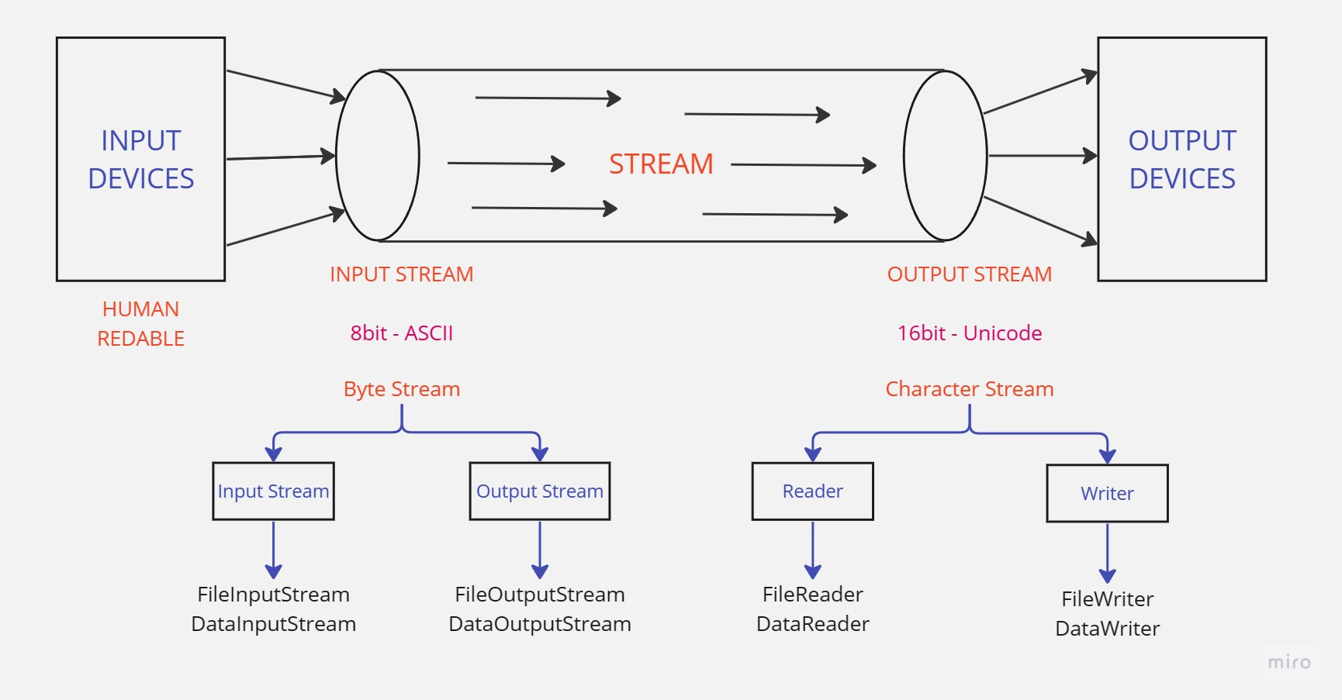

Before Unicode flow of data, it was Stream.

After supporting Unicode Character Stream, it was also called as Byte Stream.

BufferReader br = new BufferReader (new InputStreamReader(System.in));

br. read ();

br. readLine ();

**SERIALIZATION: -**

It is the process which is responsible to persist the state of object in secondary memory (file, database) for this we need to inherit serializable interface.

**DATE, TIME, DATETIME, CALENDER: -**

**(to String, hashCode, equals)**

They are legacy class and comes under java. util package. Where use before jdk8.

Now we use java. time package

localDate

localDate time

**COLLECTION FRAMEWORK: -**

This framework is responsible is responsible to collect different type of data in form of object also known as elements dynamically.

It does not support primitive data. To store it we have to convert it into object using wrapper class.

Present in java. util package.

Three types: -

Interface

Abstract

Conacred

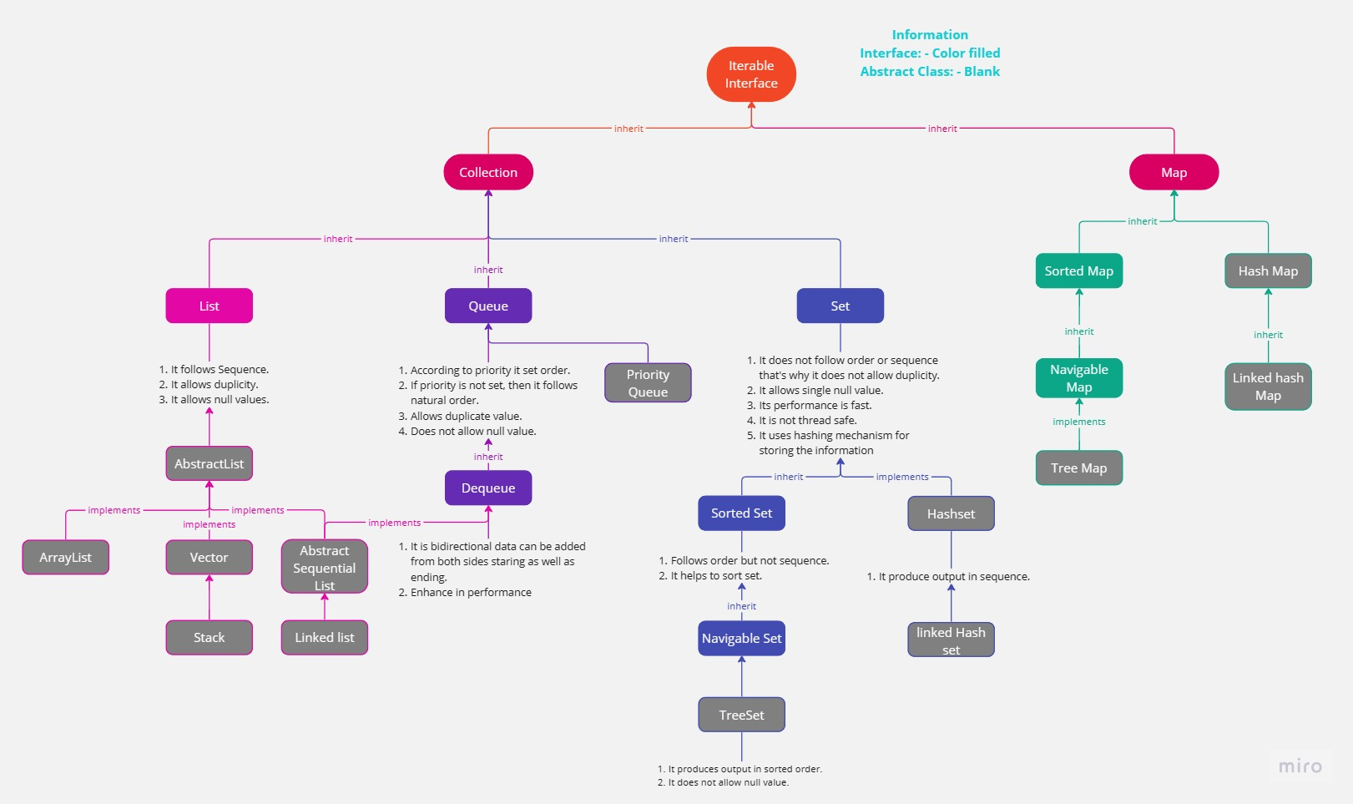

|  |  |  |  |
| --- | --- | --- | --- |
| **Arry list** | **Vector** | **Stack** | **LinkedList** |
| **Common Properties: -**  It is responsible to collect.  Follows the sequence.  It allows duplicity.  It allows null value.  **Different Properties: -** | | | |
| * It uses indexing for storing the data * It is non synchronized. * Its performance is fast for searching the data. * It performs slow for deletion and insertion of data | * It is legacy class. (v1.0) * It is synchronized by nature. * It uses indexing for storing the data * Its performance is fast for searching the data. * It performs slow for deletion and insertion of data | * It is synchronized. * It follows sequence of LIFO. * It supports indexing | * Instead of creating index it creates nodes. * It follows the mechanism of doubly linked list. * Addition and removal process becomes fast. * Performance for accessing the data is slow. |

For sorting we have two interfaces: -

Comparable: -

For natural Sorting and available for only one column.

It has method called **compareTo (o).**

Comparator: -

Can be use on “**n**”number of columns.

It has method called **compare (o1, o2).**

**Concurrency Collection: -**

Since most of the data structure in collection is supported multithreading (it is non synchronized) that’s why if multiple threads try to manipulate any data structure it may create unsafe operation and data may corrupted so for making it safe, we have the facility of concurrent collection.

**THREAD: -**

It is the path of execution of code.

Difference between thread and process: -

|  |  |
| --- | --- |
| **Process** | **Thread** |
| * Collection of thread | * It is the path of execution of code. |
| * It is heavy weighted | * It is light weighted |
| * Every process occupies its own memory space in the system | * Thread does not occupy its separate memory space. It simply shares the same space which is occupied by its corresponding process. |

**Life cycle of thread: -**

When thread is born it is called NewlyBorn.

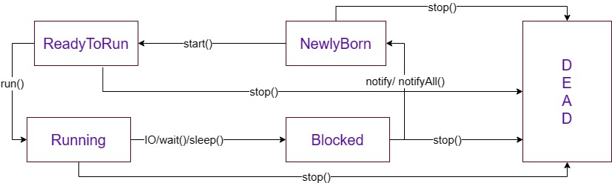

**Hierarchy of thread: -**

<Runnable>

Thread

Own Thread

**Method of threads: -**

start (): -

It is the method of thread class which is responsible to set newly born thread to readToRun stage.

run (): -

It is only method of runnable interface. In this method we need to put the code to which we need to assign thread. It will run automatically when start method is called.

sleep (): -

It is the method of thread class in which we need to pass time in milliseconds and it is responsible to block the thread for given time. The thread blocked by this method invoke automatically after completion of time.

wait (): -

It is the method of object class which is responsible to block the thread for indefinite time. So, for invoking such type of blocked thread we need to call either notify/notifyAll method.

notify / notifyAll method: -

These are the methods of object class which are responsible to invoke blocked thread.

wait (): -

It is method of thread class and responsible to achieve dead stage of thread.

**Other method of threads: -**

isAlive (): -

This method is responsible to check whether the thread is alive or not.

~~suspend ()~~: -

It is the method of thread class which is responsible to suspend the running thread.

~~resume ()~~: -

It is the method of thread class which is responsible to resume suspended thread.

yield (): -

It is the method of thread class when we called this method on any running thread then that thread paused itself momentarily and allow other wating thread for execution. After completion of execution of allowed thread, it invokes itself automatically.

join (): -

It is recommended that main thread should not exit before child thread so for achieving this recommendation we called join method on child thread than it become compulsion for main thread that it cannot exit itself without exiting child thread on which join method is called.

**We have two types of thread: -**

Demon thread: - All system defined thread belongs to this category.

**E.g.,** main thread, thread of garbage collector.

Non-Demon thread: - All user define thread belongs to this category.

**PRIORITY: -**

IT is on scale 1-10 always.

1 = minimum.

5 = normal (by default).

10 = maximum.

**E.g.,**

a 🡪 7

b 🡪 5

c 🡪 3

a. setPriority (7);

a. setPriority (Thread. MAX_PRIORITY -3); // 7

c. setPriority (b. getPriority () - 2); // 3

**SINGLE THREADING / SYNCHRONIZATION / THREAD SAFTY: -**

It is the process in which any thread can execute safely in multi-threaded environment. It is achieved by using synchronized keyword.

**E.g.,**

synchronized void Show () {……...}

**Or**

void Show () {

…….

synchronized (this) {

…………..

}

…………..

}

**DEADLOCK: -**

If multiple threads have lock on its corresponding resources and waiting for releasing other thread’s lock on its resource so that they can use it but if there is condition if all threads waiting for each other simultaneously to release their lock in that situation deadlock condition is arrived.

**GENERIC: -**

**REFLECTION API: -**

Use to do ethical hacking.